Project Brief

* The Project is named as BookIt | TasteIt.
* It is used to book the table and order the food online, so that when you think to go at a specific restaurant you will able to get a table and already ordered Food.
* Many types of restaurants and meals are available.
* It is also used to book the Parties of any type with the decoration and Meetings.

Objective

* Our motive to build this project is to overcome the problem which the customers are facing

Like not getting the table they have to wait a long, ordering the food and take time.

* In this current time, it is very hard to find the empty tables in restaurant and sometime the food we have to eat which is not available.
* They can book a table with their preferred date and time.
* So, to overcome that problem we made this project.

Technical Requirements

* Language: - Java
* JSP, Servlet, MVC to build the backend logic
* Database: - MySQL
* Secured Payment gateway (Razor pay API)
* Email Verification

**Customer Functionality**

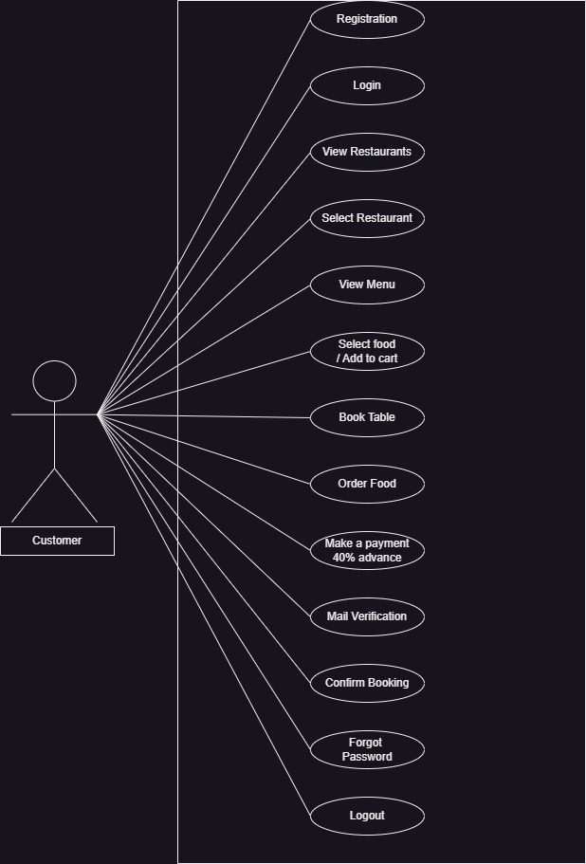

**Admin Functionality**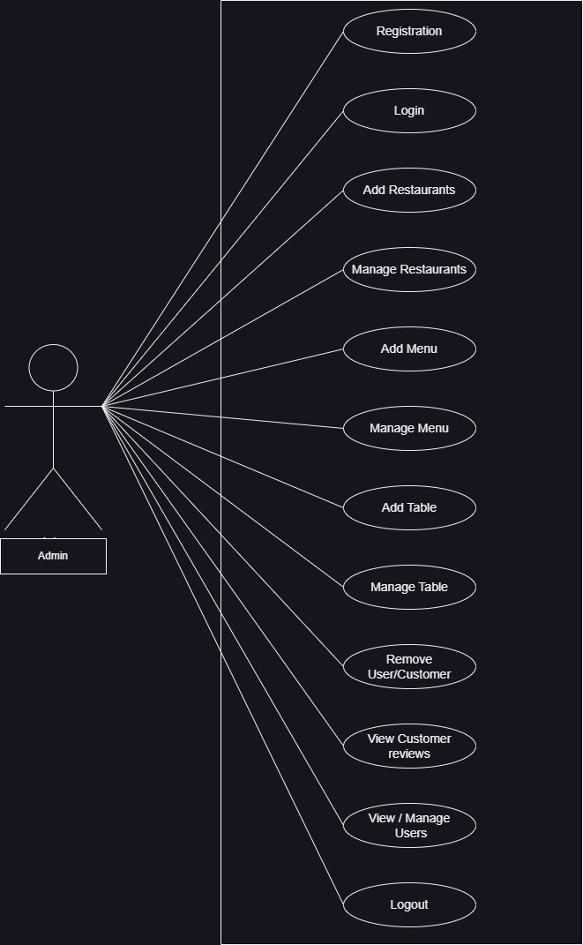

**Data Dictionary**

* Admin Table
* Customer Table
* Restaurant Table
* Food Table
* Reservation Table
* Order Table

1. Admin Table

|  |  |  |  |  |
| --- | --- | --- | --- | --- |
| Attribute | Constrain | Datatype | Size | Description |
| Adminid | Primary Key | Int | 10 | Stores the admin id |
| Uname | Not Null | Varchar | 15 | Stores the user name |
| Email | Not Null | Varchar | 30 | Stores the email id |
| Password | Not Null | Varchar | 15 | Stores the password |

1. Customer Table

|  |  |  |  |  |
| --- | --- | --- | --- | --- |
| Attribute | Constrain | Datatype | Size | Description |
| Customerid | Primary Key | Int | 10 | Stores the id |
| Firstname | Not Null | Varchar | 15 | Updates the firstname |
| Lastname | Not Null | Varchar | 15 | Updates the lastname |
| Mobno | Not Null | Varchar | 10 | Add Mobile Number |
| Email | Not Null | Varchar | 30 | Stores the email id |
| Password | Not Null | Varchar | 25 | Stores the password |

1. Restaurant Table

|  |  |  |  |  |
| --- | --- | --- | --- | --- |
| Attribute | Constrain | Datatype | Size | Description |
| Restaurantid | Primary Key | Int | 10 | Stores the unique id |
| Restaurantname | Not Null | Varchar | 30 | Stores the name |
| Restaurantimage | Not Null | Varchar | 100 | Image name & location |

1. Food Table

|  |  |  |  |  |
| --- | --- | --- | --- | --- |
| Attribute | Constrain | Datatype | Size | Description |
| Foodid | Primary key | Int | 10 | Stores the unique id |
| Foodname | Not Null | Varchar | 30 | Stores the food name |
| Foodimage | Not Null | Varchar | 100 | Image name & Location |
| Meal | Not Null | Varchar | 15 | Specify the meal (Dinner, Lunch, etc) |
| Foodprice | Not Null | Int | 10 | Stores the price of the food |
| Restaurantid | Foreign Key | Int | 10 | Connects the restaurant table |

1. Reservation Table

|  |  |  |  |  |
| --- | --- | --- | --- | --- |
| Attribute | Constrain | Datatype | Size | Description |
| Tableid | Primary key | Int | 10 | Stores the unique id |
| Tableno | Not Null | Int | 10 | Stores the table no |
| Tableprice | Not Null | Int | 10 | Stores the price of table |
| Restaurantid | Foreign Key | Int | 10 | Connects the restaurant table |

1. Order Table

|  |  |  |  |  |
| --- | --- | --- | --- | --- |
| Attribute | Constrain | Datatype | Size | Description |
| Orderid | Primary key | Int | 10 | Stores the unique id |
| Customerid | Foreign Key | Int | 10 | Connects to customer table |
| Foodid | Foreign Key | Int | 10 | Connects to Food Table |
| Restaurantid | Foreign Key | Int | 10 | Connects to Restaurant table |
| Orderdate | Not Null | Varchar | 10 | Shows the order date |
| Status | Not Null | Varchar | 10 | Shows the status of the order |